SAP Integration Suite
Cloud Integration

Technical Specification Document

gSAP_SalesConsignment_SYNRJ

Version: 1.0
Author: Generated by AI
Date: May 01, 2026
Status: Draft

Table of Contents
1. Change History
1.1 Document Control
2. Overview
2.1 Executive Summary
2.2 Purpose
2.3 Interface Requirement
2.4 Functional Assumptions
2.5 Integration Snapshot
3. High level iFlow Design
3.1 Current Scenario
3.2 To-Be Scenario
3.3 High Level Design
3.4 Technical Dependencies
4. Message Flow
4.1 Process Flow
4.2 Message Flow Connections
4.3 Integration Flow Diagram
5. Technical Description
5.1 Main Integration Process
5.2 Local Integration Process
5.3 Sender
5.4 Receiver
5.5 Mappings
5.6 Security
5.7 Groovy Scripts
5.8 Error Handling & Logging
6. Version and Metadata
7. Appendix
7.1 Technical Artifacts
7.2 Schemas
7.3 Externalized Parameters

1. Change History
Version | Date | Author | Description
1.0 | 2026-05-01 | Generated by AI | Initial autogenerated version

1.1 Document Control
- Document ID: TS-gSAP_SalesConsignment_SYNRJ
- Integration Flow: gSAP_SalesConsignment_SYNRJ
- Generated On: 2026-05-01 00:53
- Generation Mode: Batch
- Diagrams Included: Yes
- Functional Spec Context: Provided

2. Overview

2.1 Executive Summary
The gSAP_SalesConsignment_SYNRJ iFlow transfers consignment-related details (material data, orders, invoices) from a gSAP system to a SYNRJ database. This integration aims to provide SYNRJ sales personnel with a consolidated view of consignment data, improving their operational visibility.

2.2 Purpose
This document provides a technical specification for the gSAP_SalesConsignment_SYNRJ integration flow, detailing its functionality, configuration, and dependencies.

2.3 Interface Requirement
The sales people at SYNRJ would like to have a view where they can see various details related like Order no, invoice number etc. Hence SYNRJ has requested GSAP for some new transactions to provide these details. The OASIS interface will upload the data generated from GSAP into SYNRJ database.

2.4 Functional Assumptions
Assumption | Value
Frequency | Scheduled
Volume | Not specified in iFlow, needs confirmation
Processing Type | Asynchronous, XML
Performance | Not specified in iFlow, needs confirmation

2.5 Integration Snapshot
Metric | Value
Integration Processes | 2
Message Flows | 2
Sequence Flows | 12
Groovy Scripts | 2
Schemas | 0
Externalized Parameters | 61

3. High level iFlow Design

3.1 Current Scenario
As a temporary solution GSAP will send the data by files through mails. There is no automated integration between gSAP and SYNRJ for consignment data.

3.2 To-Be Scenario
The iFlow will automatically extract consignment data from gSAP using an XI sender adapter, transform it into a format suitable for the SYNRJ database via message mapping, and then insert the data into the SYNRJ database using a JDBC receiver adapter.

3.3 High Level Design
The iFlow uses an XI sender adapter to receive data from gSAP. A message mapping transforms the data, and a JDBC receiver adapter sends the transformed data to the SYNRJ database. An exception subprocess handles errors and retries the process.

3.4 Technical Dependencies
- Runtime platform: SAP CI integration flow 'gSAP_SalesConsignment_SYNRJ' orchestrates message exchange from GSAP to SYNRJ_Sales.
- Inbound interface dependency: path /gSAP_SalesConsignment/SYNRJ; XI adapter using XI over HTTP; sender auth type RoleBased with role ESBMessaging.send.
- Outbound interface dependency: URL DataPro_PricingCondition; receiver authentication type Not configured with credential/security artifact DataPro_PricingCondition.
- Security dependency: sender auth type RoleBased with user role ESBMessaging.send; receiver authentication type Not configured with credential/security artifact DataPro_PricingCondition.
- Design-time artifacts: WSDLs src\main\resources\wsdl\Insert_SalesConsignment.wsdl; src\main\resources\wsdl\SalesConsignment.wsdl | mappings src\main\resources\mapping\mm_SalesConsignment_to_InsertSalesConsignment.mmap.
- Custom script artifacts: callHeaders.groovy; GetError_log.groovy.
- Externalized runtime dependencies: 61 parameter(s) supplied, including Address, Auth, UserRole.

4. Message Flow
A message comes from GSAP into SAP CI through the configured sender channel.
SAP CI processes the payload and sends the final message to SYNRJ_Sales through the receiver channel.

4.1 Process Flow
Step | Description
1 | Step 1: gSAP system sends consignment data via XI protocol to the Integration Suite.
2 | Step 2: Integration Suite receives the message and captures the payload and relevant headers.
3 | Step 3: The message is transformed using the mm_SalesConsignment_to_InsertSalesConsignment message mapping.
4 | Step 4: The transformed message is split into individual access elements.
5 | Step 5: The individual messages are sent to the SYNRJ database via JDBC adapter.

Flow Attribute | Value
Target System | SYNRJ_Sales
Trigger | Scheduled job at GSAP

4.2 Message Flow Connections
Connection | Name
GSAP -> Start | XI
End Message -> SYNRJ_Sales | Sys_SalesConsignment_JDBC_Receiver

4.3 Integration Flow Diagram
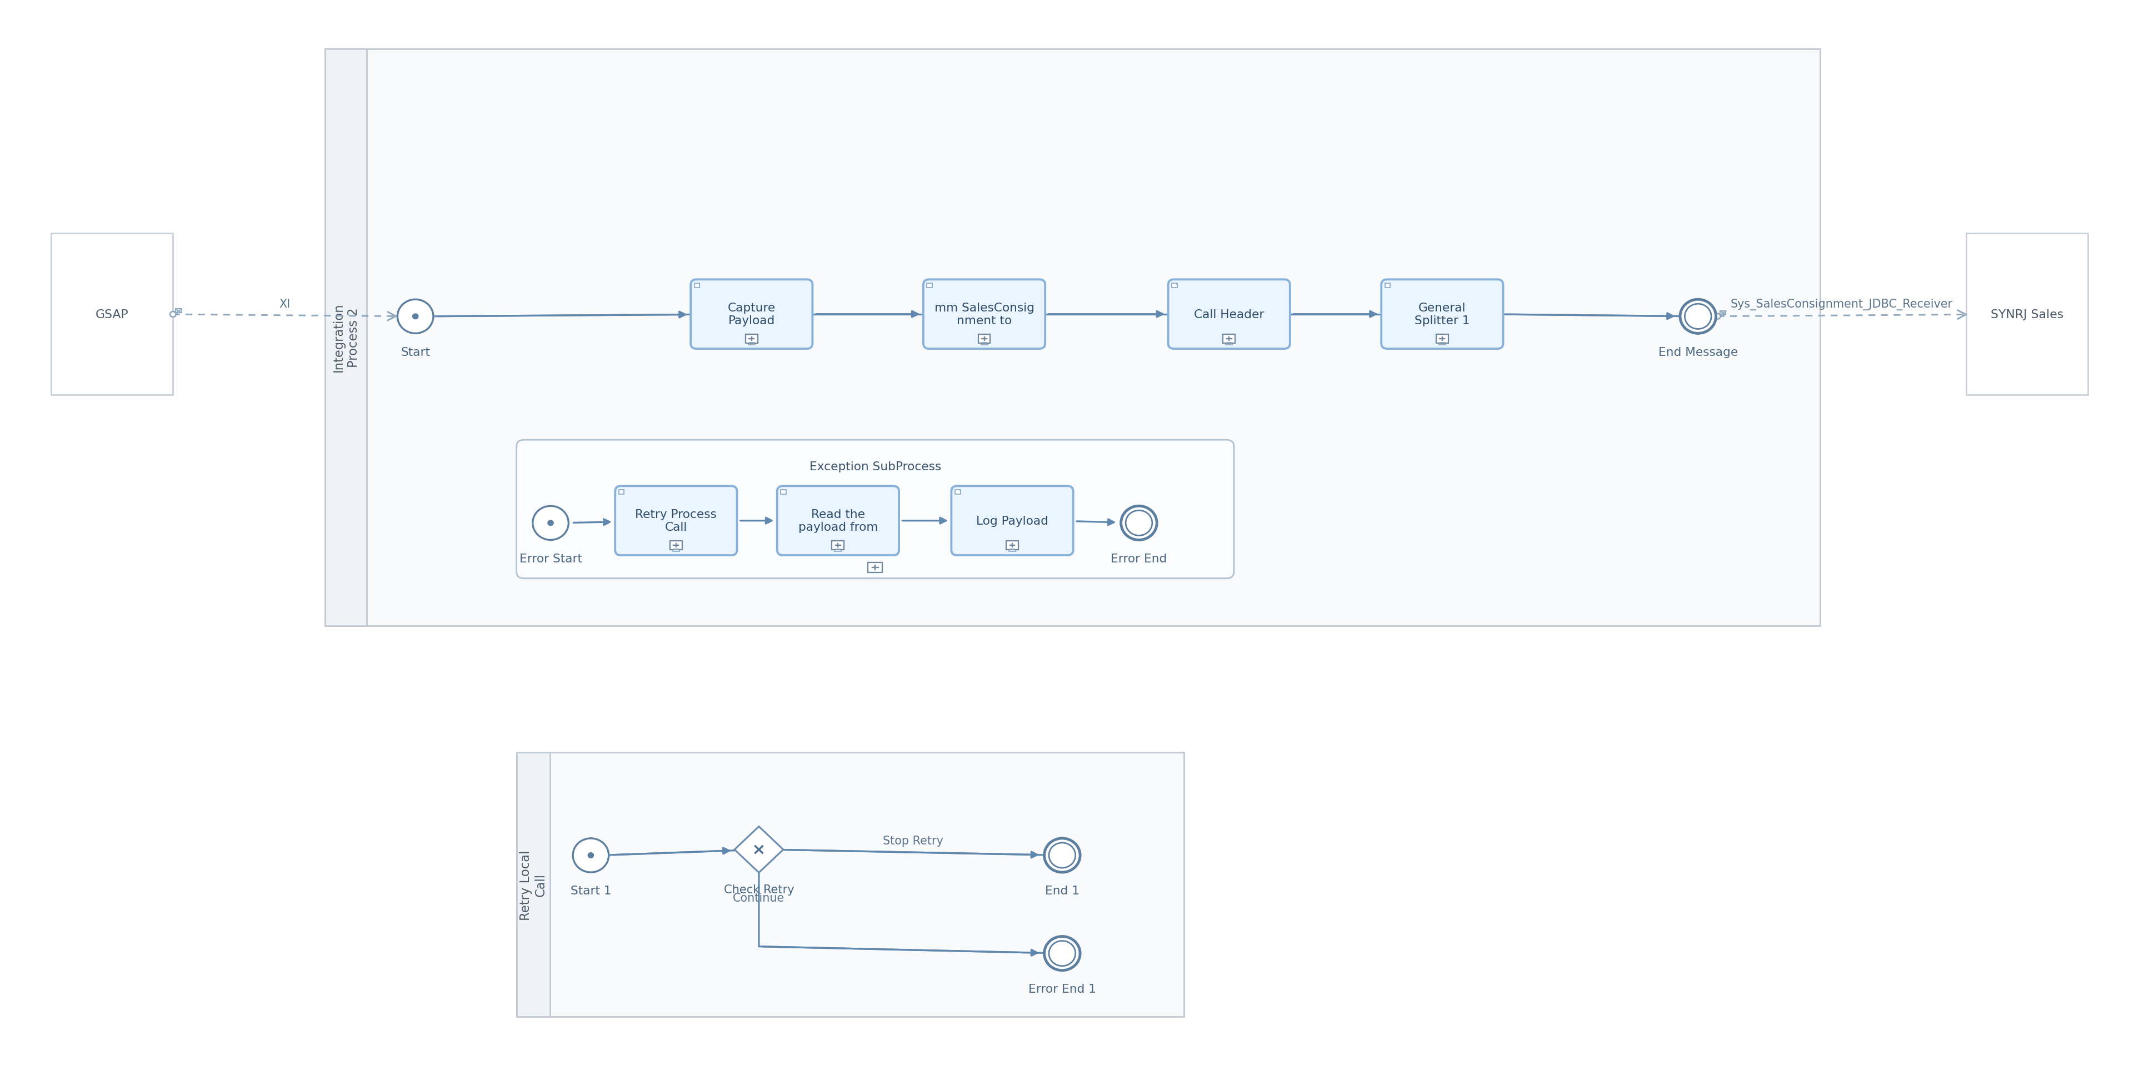
Figure: Integration Flow Diagram

5. Technical Description

5.1 Main Integration Process
Process Name | Sequence Flows | Flow Elements
Integration Process 2 | 9 | 7

Integration Process 2
This process orchestrates the main integration flow, including receiving the message, transforming the data, and sending it to the target system. It also includes an exception subprocess for error handling.
Key Activity
Enricher (Capture Payload)
Mapping (mm_SalesConsignment_to_InsertSalesConsignment)
Script (Call Header)
Splitter (General Splitter 1)

Step | Description
1 | Receive message from gSAP via XI
2 | Capture payload and headers
3 | Transform message using message mapping
4 | Call Header script
5 | Split the message
6 | Send message to SYNRJ via JDBC
7 | Handle exceptions if any

Key | Value
Transaction Timeout | 30
Transactional Handling | Not Required

callActivity Capture Payload Properties
Key | Value
Body Type | constant

callActivity General Splitter 1 Properties
Key | Value
Split Expr Value | //access

5.2 Local Integration Process
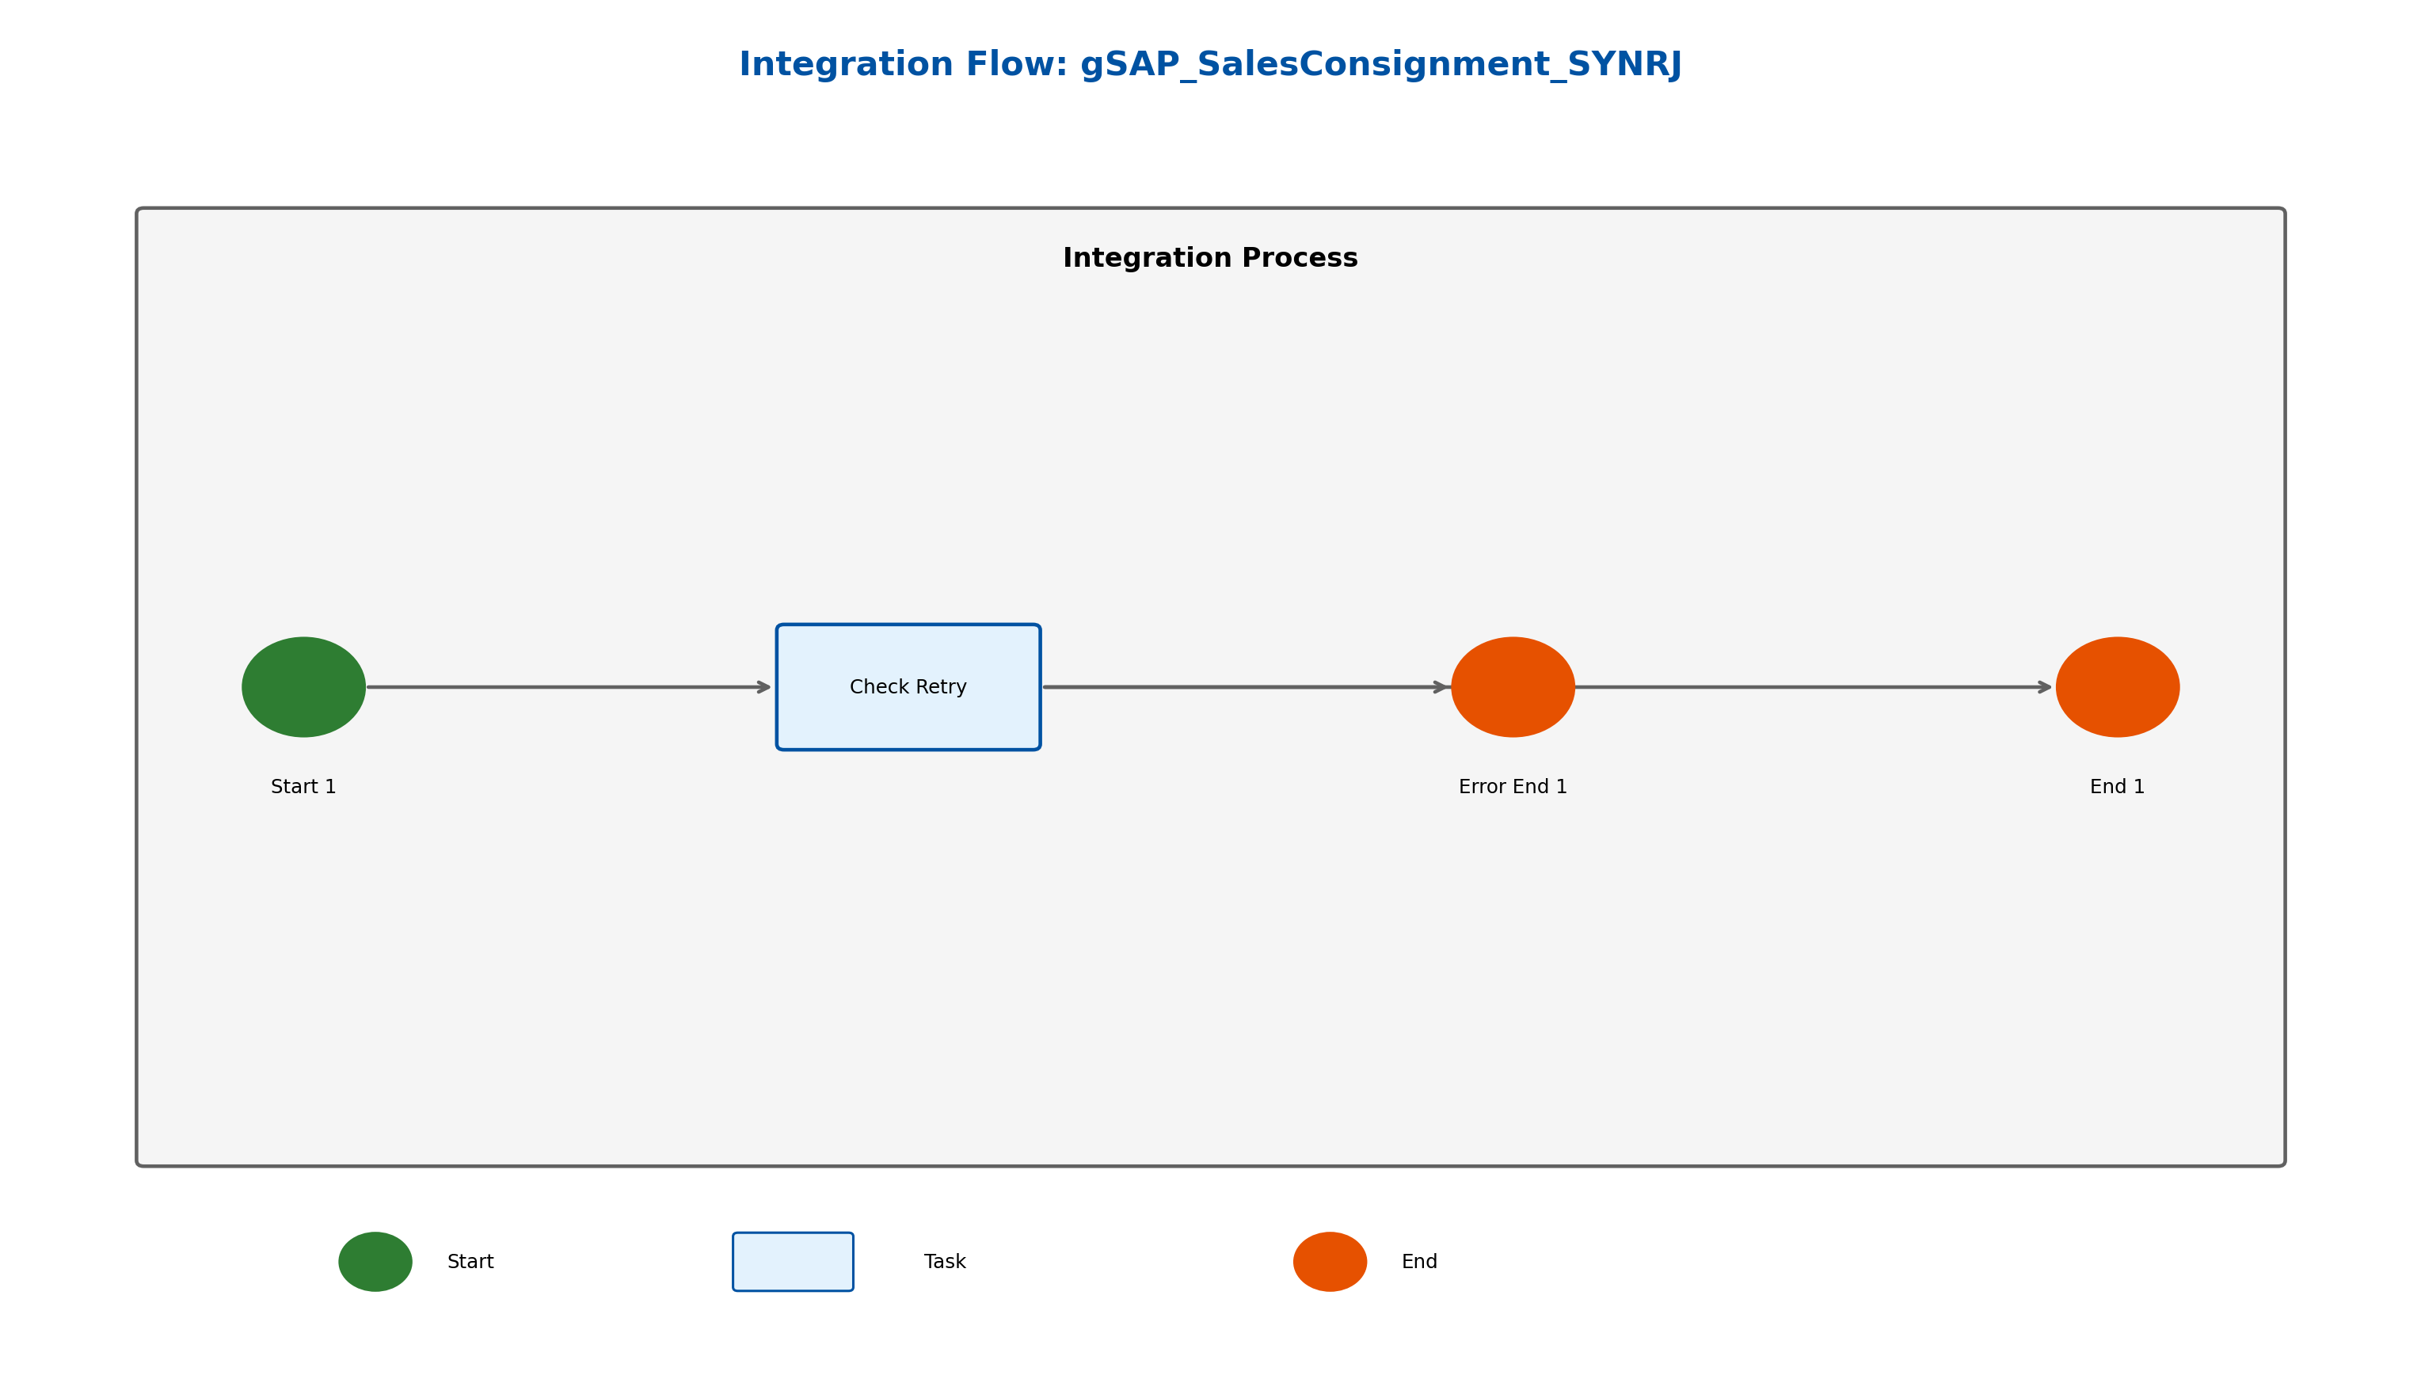
Figure: Retry Local Call Diagram

Process Name | Sequence Flows | Flow Elements
Retry Local Call | 3 | 4

Retry Local Call
This process is a local integration process called by the exception subprocess to retry the main integration flow. It checks the number of retries and either continues or stops the retry process.
Key Activity
ExclusiveGateway (Check Retry)

Step | Description
1 | Start
2 | Check Retry
3 | Continue or Stop Retry

Key | Value
Transaction Timeout | 30
Process Type | directCall
Transactional Handling | From Calling Process

exclusiveGateway Check Retry Properties
Key | Value
Throw Exception | false

sequenceFlow Continue Properties
Key | Value
Expression Type | XML

sequenceFlow Stop Retry Properties
Key | Value
Expression Type | NonXML

5.3 Sender
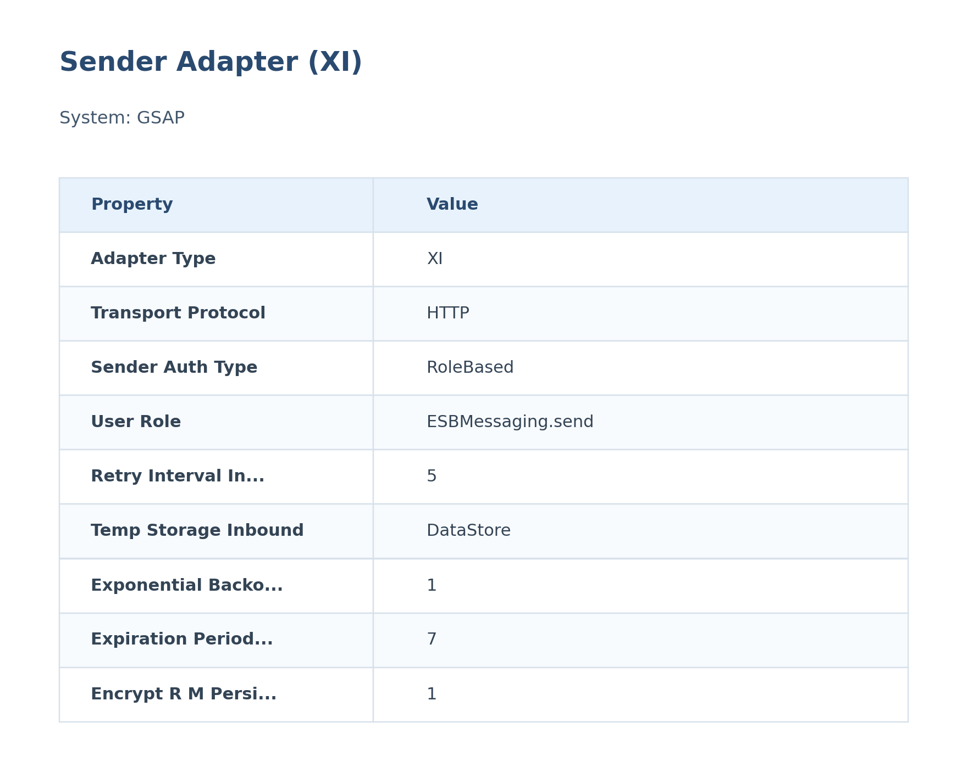
Figure: Sender Configuration

The XI sender adapter receives messages from the gSAP system. It uses the HTTP protocol and XI message protocol. Authentication is configured via adapter properties.
Attribute | Value
Path / Address | /gSAP_SalesConsignment/SYNRJ
Adapter Type | XI
Protocol | XI over HTTP
Auth Type | RoleBased
User Role | ESBMessaging.send

5.4 Receiver
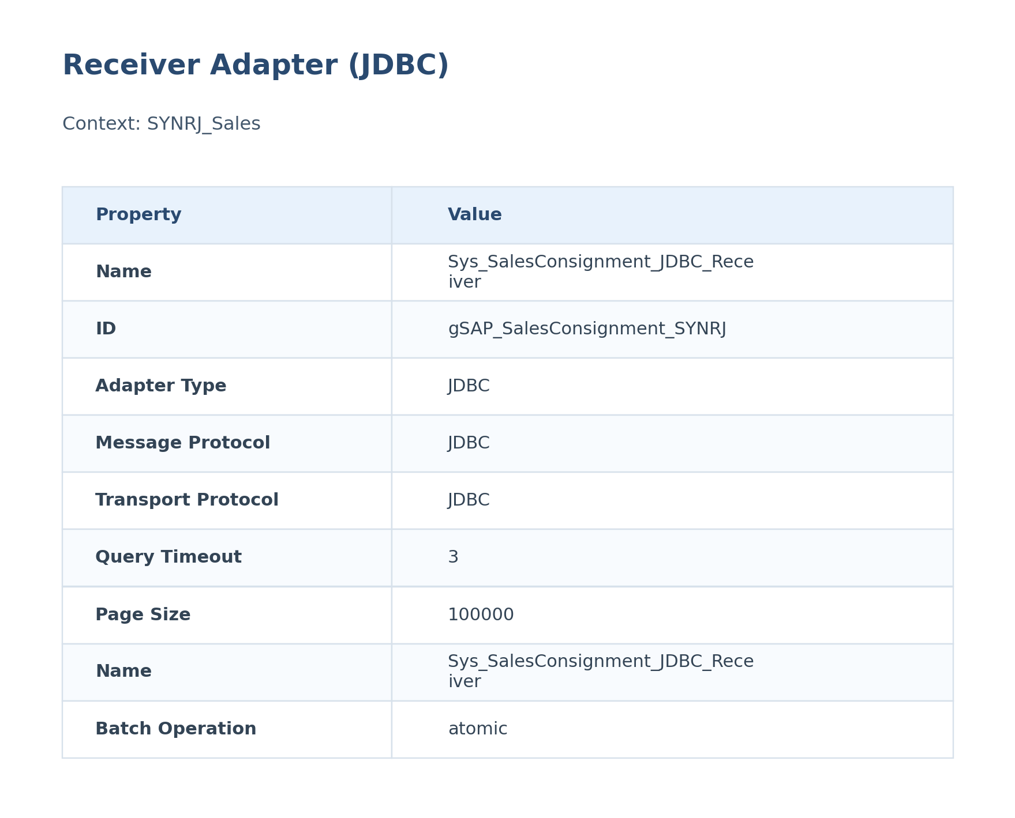
Figure: Receiver Configuration

The JDBC receiver adapter sends data to the SYNRJ database. It uses the JDBC protocol and the connection is configured via a connection alias.
Attribute | Value
URL / Address | DataPro_PricingCondition
Adapter Type | JDBC
Authentication Type | Not configured
Credential / Security Artifact | DataPro_PricingCondition
Operation Name | Not configured

5.5 Mappings

mm_SalesConsignment_to_InsertSalesConsignment
This mapping transforms SalesConsignment data into the InsertSalesConsignment structure used later in SAP CI.
It is executed during message processing to reshape the payload before the next handoff.
Attribute | Value
Source Message / Object | SalesConsignment
Target Message / Object | InsertSalesConsignment
Mapping File | src\main\resources\mapping\mm_SalesConsignment_to_InsertSalesConsignment.mmap

5.6 Security
Security Aspect | Details
Authentication | Configured via XI sender adapter properties (ESBMessaging.send, RoleBased).
Authorization | Not explicitly defined in iFlow.
Encryption | TLS/SSL details not explicitly defined in iFlow.

Key | Value
Namespace Mapping | xmlns:p1=urn:syngenta.com:I_SAP_R3_CP_Global_GSAP:cp:global:Sales
Http Session Handling | None
Return Exception To Sender | false
Log | All events
Cors Enabled | false
Server Trace | false
Access Control Allow Credentials | false

5.7 Groovy Scripts
Groovy scripts are used in this iFlow for logging header properties and payload. These scripts enhance monitoring and debugging capabilities.

callHeaders.groovy
This script logs header properties such as Country, Region, BusinessObject, Sender, Receiver, TimeStamp, InvoiceNum, and SAP_ApplicationID to the message log.
[Groovy]
import com.sap.gateway.ip.core.customdev.util.Message;
def Message processData(Message message) {
def messageLog = messageLogFactory.getMessageLog(message);
if(messageLog != null){
def Country = message.getHeaders().get("Country");
if(Country!=null){
messageLog.addCustomHeaderProperty("Country", Country);
}
def Region = message.getHeaders().get("Region");
if(Region!=null){
messageLog.addCustomHeaderProperty("Region", Region);
}
def BusinessObject = message.getHeaders().get("BusinessObject");
if(BusinessObject!=null){
messageLog.addCustomHeaderProperty("BusinessObject", BusinessObject);
}
def Sender = message.getHeaders().get("Sender");
if(Sender!=null){
messageLog.addCustomHeaderProperty("Sender", Sender);
}
def Receiver = message.getHeaders().get("Receiver");
if(Receiver!=null){
messageLog.addCustomHeaderProperty("Receiver", Receiver);
}
def TimeStamp = message.getHeaders().get("TimeStamp");
if(TimeStamp!=null){
messageLog.addCustomHeaderProperty("TimeStamp", TimeStamp);
}
def InvoiceNum = message.getHeaders().get("InvoiceNum");
if(InvoiceNum!=null){
messageLog.addCustomHeaderProperty("InvoiceNum", InvoiceNum);
}
def SAP_ApplicationID = message.getHeaders().get("SAP_ApplicationID");
if(SAP_ApplicationID!=null){
messageLog.addCustomHeaderProperty("SAP_ApplicationID", SAP_ApplicationID);
}
}
return message;
}

GetError_log.groovy
This script logs the SAP Quotation Payload, SFDC Look-Up Payload, Map SFDC Query Payload, and Error Log as attachments to the message log. It also includes a method to disable log attachments.
[Groovy]
import com.sap.gateway.ip.core.customdev.util.Message;
import java.util.HashMap;
import java.text.SimpleDateFormat;
// Save SAP Quotation Payload
def Message logPayloadSAP(Message message) {
def body = message.getBody(java.lang.String) as String;
def messageLog = messageLogFactory.getMessageLog(message);
messageLog.addAttachmentAsString("1# SAP Quotation Payload", body, "text/xml");
return message;
}
// Save Payload after SFDC Look-Up
def Message logLookUpSFDC(Message message) {
def body = message.getBody(java.lang.String) as String;
def messageLog = messageLogFactory.getMessageLog(message);
messageLog.addAttachmentAsString("2# LookUP SFDC", body, "text/plain");
return message;
}
// Save Payload after Map to XSD SAP Proxy
def Message logMapSFDC(Message message) {
def body = message.getBody(java.lang.String) as String;
def messageLog = messageLogFactory.getMessageLog(message);
messageLog.addAttachmentAsString("2# Map SFDC Query", body, "text/xml");
return message;
}
// Log Error
def Message logError(Message message) {
def body = message.getBody(java.lang.String) as String;
def messageLog = messageLogFactory.getMessageLog(message);
messageLog.addAttachmentAsString("Error Log", body, "text/xml");
return message;
}
//Method to disable log attached
def Message logDisable(Message message) {
return message;
}

5.8 Error Handling & Logging
Aspect | Details
Description | The iFlow includes an exception subprocess to handle errors. The exception subprocess logs the payload, retries the process, and ends with an error end event.
Exception Handling | The exception subprocess includes a 'Retry Process Call' activity that calls the 'Retry Local Call' process. The 'Retry Local Call' process checks the number of retries and either continues or stops the retry process.
Alerting | Alerting is not explicitly configured in the iFlow.
Retry Logic | The iFlow includes a retry mechanism via the 'Retry Local Call' process. The retry logic checks the number of retries and either continues or stops the retry process based on the condition ${header.SAP_DataStoreRetries} > '2'.

Exception SubProcess Diagram
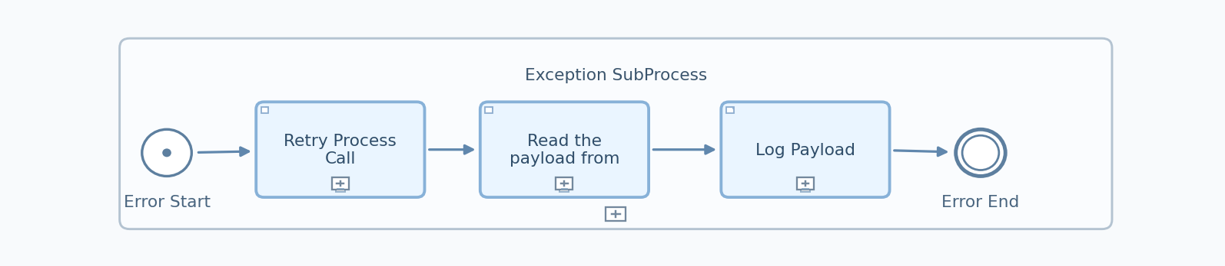
Figure: Exception SubProcess (Copied from Integration Flow Diagram)

Exception SubProcess 1 Properties

Child Element: callActivity Log Payload
Key | Value
subActivityType | GroovyScript
script | Log_Payload.gsh

Child Element: callActivity Retry Process Call
Key | Value
processId | Process_10051
subActivityType | NonLoopingProcess

Child Element: callActivity Read the payload from property
Key | Value
bodyType | expression
wrapContent | ${property.InputPayload}

6. Version and Metadata
Key | Value
Componentversion | 1.0
Version | 1.2
Package | Not found in iFlow
Author | Not found in iFlow
Description | Default Collaboration

7. Appendix

7.1 Technical Artifacts
- iFlow: gSAP_SalesConsignment_SYNRJ.iflw
- Groovy Script: callHeaders.groovy
- Groovy Script: GetError_log.groovy
- Message Flows: 2
- Sequence Flows: 12
- Mapping Activities: 1
- callHeaders.groovy
- GetError_log.groovy
- mm_SalesConsignment_to_InsertSalesConsignment.mmap
- SalesConsignment.wsdl
- Insert_SalesConsignment.wsdl
- Log_Payload.gsh

7.3 Externalized Parameters
Parameter | Value | Used In
Address | /gSAP_SalesConsignment/SYNRJ | Sender - Address Inbound
Attachments | 100 | Sender - Maximum Attachment Size
Auth | RoleBased | Sender - Sender Auth Type
Backoff | 1 | Sender - Exponential Backoff Inbound
Component | DefaultXIService | Sender - Communication Component Receiver
Interval | 1 | Sender - Poll Delay Inbound
Maximum | 60 | Sender - Max Retry Interval Inbound
MessageFlow_3_alias | DataPro_PricingCondition | Receiver - Alias
MessageFlow_3_batchMode | 0 | Receiver - Batch Mode
MessageFlow_3_connectionTimeout | 3 | Receiver - Connection Timeout
MessageFlow_3_pageSize | 100000 | Receiver - Page Size
MessageFlow_3_queryTimeout | 3 | Receiver - Query Timeout
Party | Not configured | Sender - Communication Party Receiver
Period | 7 | Sender - Expiration Period Inbound
Persistence | 1 | Sender - Encrypt R M Persistence Inbound
Retry_ | 5 | Sender - Retry Interval Inbound
Service | ExactlyOnce | Sender - Quality Of Service Inbound
Size | 40 | Sender - Maximum Body Size
Temp | DataStore | Sender - Temp Storage Inbound
Timeout | 10 | Sender - Lock Timeout Inbound
UserRole | ESBMessaging.send | Sender - User Role

